

UNIVERSIDAD DE GUAYAQUIL
FACULTAD DE CIENCIAS, MATEMATICAS Y FISICAS
CARRERA DE SOFTWARE

MATERIA:
DESARROLLO DE APLICACIONES MOVILES

TEMA DE ACTIVIDAD:
FLUTTER

DOCENTE:
ING. CHARCO AGUIRRE JORGE LUIS

ESTUDIANTE:
FREIRE VERA JOSUE ANIBAL

CICLO ESCOLAR:
2025 – 2026 CICLO 2

INDICE
CODIGOS 1
Main.dart 1
Ventana_principal.dart 4
Ventana_registro.dart 4
Pubspec.yaml 7
PANTALLAS EN EJECUCION 10
LINK DEL REPOSITORIO DEL PROYECTO Y VIDEO EXPLICATIVO 11

CODIGOS

Main.dart
import 'package:flutter/material.dart';
import 'ventana_registro.dart';
import 'ventana_principal.dart';

void main() {
runApp(const MyApp());
}

class MyApp extends StatelessWidget {
const MyApp({super.key});

@override
Widget build(BuildContext context) {
return MaterialApp(
debugShowCheckedModeBanner: false,
home: const LoginPage(),
);
}
}

class LoginPage extends StatefulWidget {
const LoginPage({super.key});

@override
State<LoginPage> createState() => _LoginPageState();
}

class _LoginPageState extends State<LoginPage> {
final _formKey = GlobalKey<FormState>();
final emailController = TextEditingController();
final passwordController = TextEditingController();

void ingresar() {
if (_formKey.currentState!.validate()) {
if (emailController.text == UsuarioRegistrado.email &&
passwordController.text == UsuarioRegistrado.clave) {
print("Acceso concedido");

Navigator.push(
context,
MaterialPageRoute(builder: (_) => const VentanaPrincipal()),
);
} else {
print("Acceso Negado");
}
}
}

void registrarse() {
print("Va a registrar un nuevo usuario");

ScaffoldMessenger.of(context).showSnackBar(
const SnackBar(
content: Text("Va a registrar un nuevo usuario"),
backgroundColor: Colors.blue,
),
);

Navigator.push(
context,
MaterialPageRoute(builder: (_) => const VentanaRegistro()),
);
}

@override
Widget build(BuildContext context) {
return Scaffold(
body: Stack(
children: [
// Fondo
Container(
decoration: const BoxDecoration(
image: DecorationImage(
image: AssetImage("assets/images/fondo.png"),
fit: BoxFit.cover,
),
),
),

// Contenido
Center(
child: Container(
padding: const EdgeInsets.all(20),
margin: const EdgeInsets.symmetric(horizontal: 25),
decoration: BoxDecoration(
color: Colors.white.withOpacity(0.9),
borderRadius: BorderRadius.circular(15),
),
child: Form(
key: _formKey,
child: Column(
mainAxisSize: MainAxisSize.min,
children: [
const Text(
"Josue Freire",
style: TextStyle(
fontSize: 22,
fontWeight: FontWeight.bold,
color: Colors.blue,
),
),

const SizedBox(height: 20),

TextFormField(
controller: emailController,
decoration: const InputDecoration(
labelText: "Correo electrónico",
prefixIcon: Icon(Icons.email),
border: OutlineInputBorder(),
),
validator: (value) =>
value!.isEmpty ? "Campo obligatorio" : null,
),

const SizedBox(height: 15),

TextFormField(
controller: passwordController,
obscureText: true,
decoration: const InputDecoration(
labelText: "Clave",
prefixIcon: Icon(Icons.lock),
border: OutlineInputBorder(),
),
validator: (value) =>
value!.isEmpty ? "Campo obligatorio" : null,
),

const SizedBox(height: 20),

SizedBox(
width: double.infinity,
child: ElevatedButton(
onPressed: ingresar,
style: ElevatedButton.styleFrom(
backgroundColor: Colors.green,
padding: const EdgeInsets.symmetric(vertical: 14),
),
child: const Text(
"Ingresar",
style: TextStyle(color: Colors.black),
),
),
),

TextButton(
onPressed: registrarse,
child: const Text("Registrarse"),
),
],
),
),
),
),
],
),
);
}
}

// Usuario en memoria (para clase)
class UsuarioRegistrado {
static String email = "admin@correo.com";
static String clave = "123456";
}

Ventana_principal.dart
import 'package:flutter/material.dart';

class VentanaPrincipal extends StatelessWidget {
const VentanaPrincipal({super.key});

@override
Widget build(BuildContext context) {
return Scaffold(
appBar: AppBar(title: const Text("Ventana Principal")),
body: const Center(
child: Text(
"Bienvenido al sistema",
style: TextStyle(fontSize: 22),
),
),
);
}
}

Ventana_registro.dart
import 'package:flutter/material.dart';
import 'main.dart';

class VentanaRegistro extends StatefulWidget {
const VentanaRegistro({super.key});

@override
State<VentanaRegistro> createState() => _VentanaRegistroState();
}

class _VentanaRegistroState extends State<VentanaRegistro> {
final _formKey = GlobalKey<FormState>();
final emailController = TextEditingController();
final passwordController = TextEditingController();

void registrar() {
if (_formKey.currentState!.validate()) {
UsuarioRegistrado.email = emailController.text;
UsuarioRegistrado.clave = passwordController.text;

print("Usuario registrado correctamente");

ScaffoldMessenger.of(context).showSnackBar(
const SnackBar(
content: Text("Usuario registrado correctamente"),
backgroundColor: Colors.green,
),
);

Navigator.pop(context);
}
}

@override
Widget build(BuildContext context) {
return Scaffold(
appBar: AppBar(
title: const Text("Registro"),
backgroundColor: Colors.green,
foregroundColor: Colors.black,
centerTitle: true,
),
body: Center(
child: Container(
padding: const EdgeInsets.all(25),
margin: const EdgeInsets.symmetric(horizontal: 30),
decoration: BoxDecoration(
color: Colors.white,
borderRadius: BorderRadius.circular(20),
boxShadow: const [
BoxShadow(
blurRadius: 10,
color: Colors.black26,
)
],
),
child: Form(
key: _formKey,
child: Column(
mainAxisSize: MainAxisSize.min,
children: [
const Text(
"Josue Freire - Registro de Usuario",
textAlign: TextAlign.center,
style: TextStyle(
fontSize: 22,
fontWeight: FontWeight.bold,
color: Colors.black,
),
),

const SizedBox(height: 25),

TextFormField(
controller: emailController,
decoration: const InputDecoration(
labelText: "Correo",
labelStyle: TextStyle(color: Colors.black),
prefixIcon: Icon(Icons.email, color: Colors.black),
border: OutlineInputBorder(),
),
validator: (value) =>
value!.isEmpty ? "Campo obligatorio" : null,
),

const SizedBox(height: 15),

TextFormField(
controller: passwordController,
obscureText: true,
decoration: const InputDecoration(
labelText: "Clave",
labelStyle: TextStyle(color: Colors.black),
prefixIcon: Icon(Icons.lock, color: Colors.black),
border: OutlineInputBorder(),
),
validator: (value) =>
value!.isEmpty ? "Campo obligatorio" : null,
),

const SizedBox(height: 25),

SizedBox(
width: double.infinity,
child: ElevatedButton(
onPressed: registrar,
style: ElevatedButton.styleFrom(
backgroundColor: Colors.green,
padding: const EdgeInsets.symmetric(vertical: 14),
),
child: const Text(
"Registrar",
style: TextStyle(color: Colors.black),
),
),
),
],
),
),
),
),
);
}
}

Pubspec.yaml
name: flutter_freire_vera
description: "A new Flutter project."
# The following line prevents the package from being accidentally published to
# pub.dev using `flutter pub publish`. This is preferred for private packages.
publish_to: 'none' # Remove this line if you wish to publish to pub.dev

# The following defines the version and build number for your application.
# A version number is three numbers separated by dots, like 1.2.43
# followed by an optional build number separated by a +.
# Both the version and the builder number may be overridden in flutter
# build by specifying --build-name and --build-number, respectively.
# In Android, build-name is used as versionName while build-number used as versionCode.
# Read more about Android versioning at https://developer.android.com/studio/publish/versioning
# In iOS, build-name is used as CFBundleShortVersionString while build-number is used as CFBundleVersion.
# Read more about iOS versioning at
# https://developer.apple.com/library/archive/documentation/General/Reference/InfoPlistKeyReference/Articles/CoreFoundationKeys.html
# In Windows, build-name is used as the major, minor, and patch parts
# of the product and file versions while build-number is used as the build suffix.
version: 1.0.0+1

environment:
sdk: ^3.10.4

# Dependencies specify other packages that your package needs in order to work.
# To automatically upgrade your package dependencies to the latest versions
# consider running `flutter pub upgrade --major-versions`. Alternatively,
# dependencies can be manually updated by changing the version numbers below to
# the latest version available on pub.dev. To see which dependencies have newer
# versions available, run `flutter pub outdated`.
dependencies:
flutter:
sdk: flutter

# The following adds the Cupertino Icons font to your application.
# Use with the CupertinoIcons class for iOS style icons.
cupertino_icons: ^1.0.8

dev_dependencies:
flutter_test:
sdk: flutter

# The "flutter_lints" package below contains a set of recommended lints to
# encourage good coding practices. The lint set provided by the package is
# activated in the `analysis_options.yaml` file located at the root of your
# package. See that file for information about deactivating specific lint
# rules and activating additional ones.
flutter_lints: ^6.0.0

# For information on the generic Dart part of this file, see the
# following page: https://dart.dev/tools/pub/pubspec

# The following section is specific to Flutter packages.
flutter:

# The following line ensures that the Material Icons font is
# included with your application, so that you can use the icons in
# the material Icons class.
uses-material-design: true

assets:
- assets/fondo.png

# To add assets to your application, add an assets section, like this:
# assets:
# - images/a_dot_burr.jpeg
# - images/a_dot_ham.jpeg

# An image asset can refer to one or more resolution-specific "variants", see
# https://flutter.dev/to/resolution-aware-images

# For details regarding adding assets from package dependencies, see
# https://flutter.dev/to/asset-from-package

# To add custom fonts to your application, add a fonts section here,
# in this "flutter" section. Each entry in this list should have a
# "family" key with the font family name, and a "fonts" key with a
# list giving the asset and other descriptors for the font. For
# example:
# fonts:
# - family: Schyler
# fonts:
# - asset: fonts/Schyler-Regular.ttf
# - asset: fonts/Schyler-Italic.ttf
# style: italic
# - family: Trajan Pro
# fonts:
# - asset: fonts/TrajanPro.ttf
# - asset: fonts/TrajanPro_Bold.ttf
# weight: 700
#
# For details regarding fonts from package dependencies,
# see https://flutter.dev/to/font-from-package

PANTALLAS EN EJECUCION
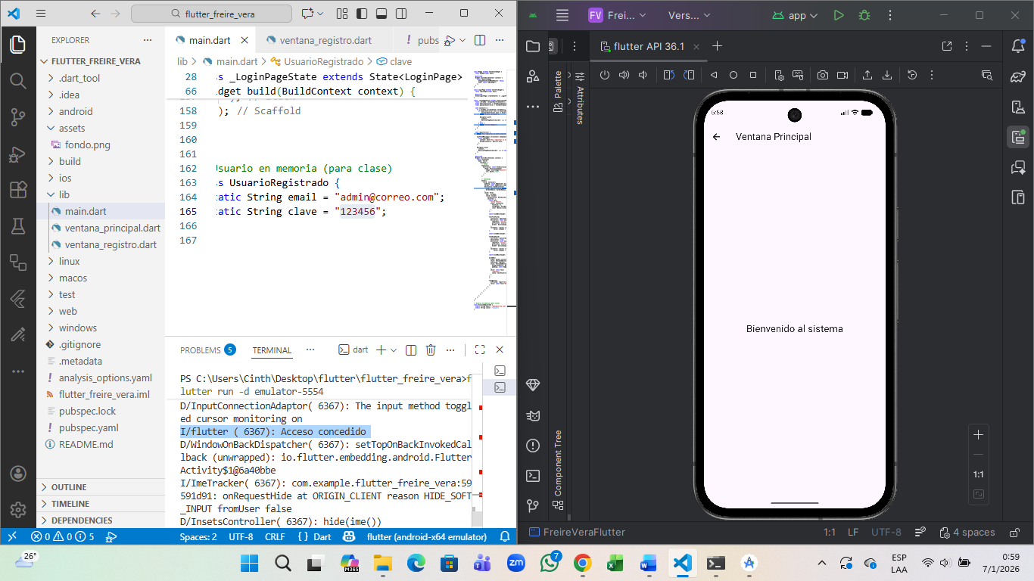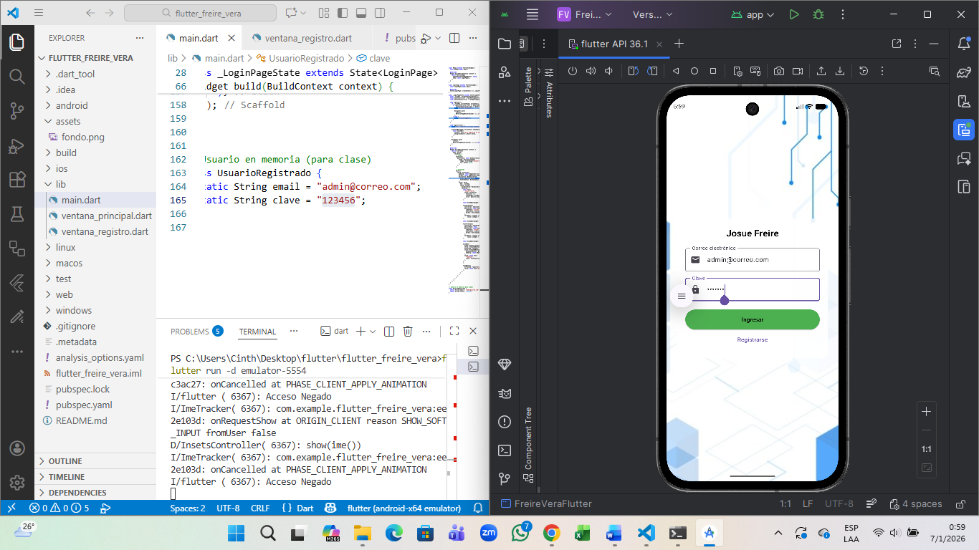
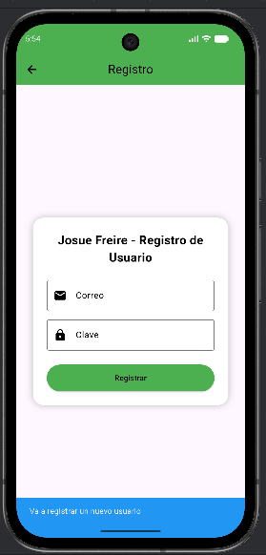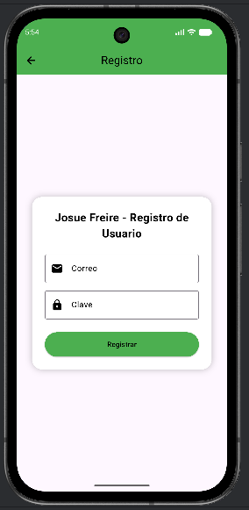

LINK DEL REPOSITORIO DEL PROYECTO Y VIDEO EXPLICATIVO
https://drive.google.com/drive/folders/1fuln9HbWm9_SE9fq-ABxrM-X-W45wi8j?usp=sharing

